**PROJECT REPORT**

**ON**

**“QUOTES YOU”**

**FOR**

**IT54L: MINI PROJECT USING MOBILE APPLICATION DEVELOPMENT**

**BY**

**SABIHA VORA**

**SAVITRIBAI PHULE PUNE UNIVERSITY**

**MASTERS OF COMPUTER APPLICATION**

**M.C.E. SOCIETY’S**

**ALLANA INSTITUTE OF MANAGEMENT SCIENCES, PUNE**

**2018-2019**

**DECLARATION**

I hereby declare that the project work entitled “QUOTES YOU” submitted to the Savitribai Phule Pune University, Pune, is a record of an original work done by, and this project work is submitted in the partial fulfillment of the requirements for the course of IT54L: Mini Project using Mobile Application Course for semester V of the degree of Master of Computer Application.

Date: Signature of the Candidate

|  |  |
| --- | --- |
| **Index** | Page Number |
| 1. **Introduction And Synopsis**    1. **Existing System And Need For System**    2. **Scope Of Work**    3. **Operating Environment**   **-Hardware Requirements**  **-Software Requirements** |  |
| 1. **Proposed System**    1. **Proposed System**    2. **Objective of System**    3. **User Requirements** |  |
| 1. **ANALYSIS AND DESIGN**    1. **Class Diagram**    2. **Use case Diagram**    3. **User Interface Design**    4. **Table specifications** |  |
| 1. **Drawbacks and Limitations** 2. **Proposed Enhancements** 3. **Conclusion** 4. **Bibliography**   **ANNEXURES:**  **ANNEXURE 1 : OUTPUT REPORTS WITH DATA**  **ANNEXURE 2 : PROGRAM CODE** |  |

1. **Introduction and Synopsis**
   1. **Existing System and Need for System**

Increasingly developed social sharing sites like Pinterest, Brainy Quotes allow users to create, share, annotate and comment on quotes. The large-scale user generated meta data not only facilitate users in sharing and organizing multimedia content, but provide useful information to improve media retrieval and management. Personalized quotes and upgrades serve as one of such examples where the creation of quotes by the user’s experience is improved by creating their own quotes.

In Existing System, Users may have different aims for the same query, e.g., searching for a quote by a particular author has a completely different meaning from the original quote quoted. One solution for these problems is personalized search, where user-specific information is considered to distinguish the exact intentions of the user queries and re-rank the list results.

**1.2 Scope of Work**

The scope of this project is that the user can create a personalize quote and can upload with the user’s credentials, time and date.

Also, the database will store the data and will not duplicate the user’s content.

**1.3 Operating Environment**

**Hardware Requirement**

* Operating system: Microsoft Windows 7,8,10(32 or 64 bit)
* RAM: 8 GB RAM + 2GB for emulator
* Coding Language: Java
* Tool Kit: Android SDK 3.2.1

**Software Requirement:**

* IDE: Eclipse or Android Studio
* Android SDK (Software development kit)

**2. Proposed System**

**2.1 Proposed System**

In proposed system we propose a novel personalized quotes framework by considering user’s content information. The user’s preferences over quotes under certain query is estimated by how probable he/she assigns the query related to the quotes.

Modules:

User-Specific Topic Modeling:

User’s may have different intentions, ideas for the particular quote but the meaning changes completely when the search results pop up. So, it becomes necessary to make user specific personalized search where the user can distinguish between what he/she intents and what results he/she requires.

Keep a Check:

The user can upload the quotes with all the credentials needed so that no other person can plagiarize the user’s quotes or copy paste somewhere by editing the contents.

So, this module provides a mechanism of keeping a check on the user’s content which is being uploaded.

Notifications:

The user can be notified for how many times his/her quotes is being liked and shared.

**2.3 Objective of the System**

The objective of the system is to provide user’s content on web and enable the user to keep a check on the uploaded content. The user is notified of the likes and shares via the application and can also manage the quotes by saving, updating or deleting it.

**2.4 User Requirements**

The user can register if not registered and then can login to the application.

The quotes can be added via images or text.

The system provides the user to input the necessary credentials so that the user’s identity is identified and no plagiarism takes place.

The user can upload his/quotes and can be notified of the likes and shares.

**3.ANALYSIS AND DESIGN**

**3.1 Class Diagram**

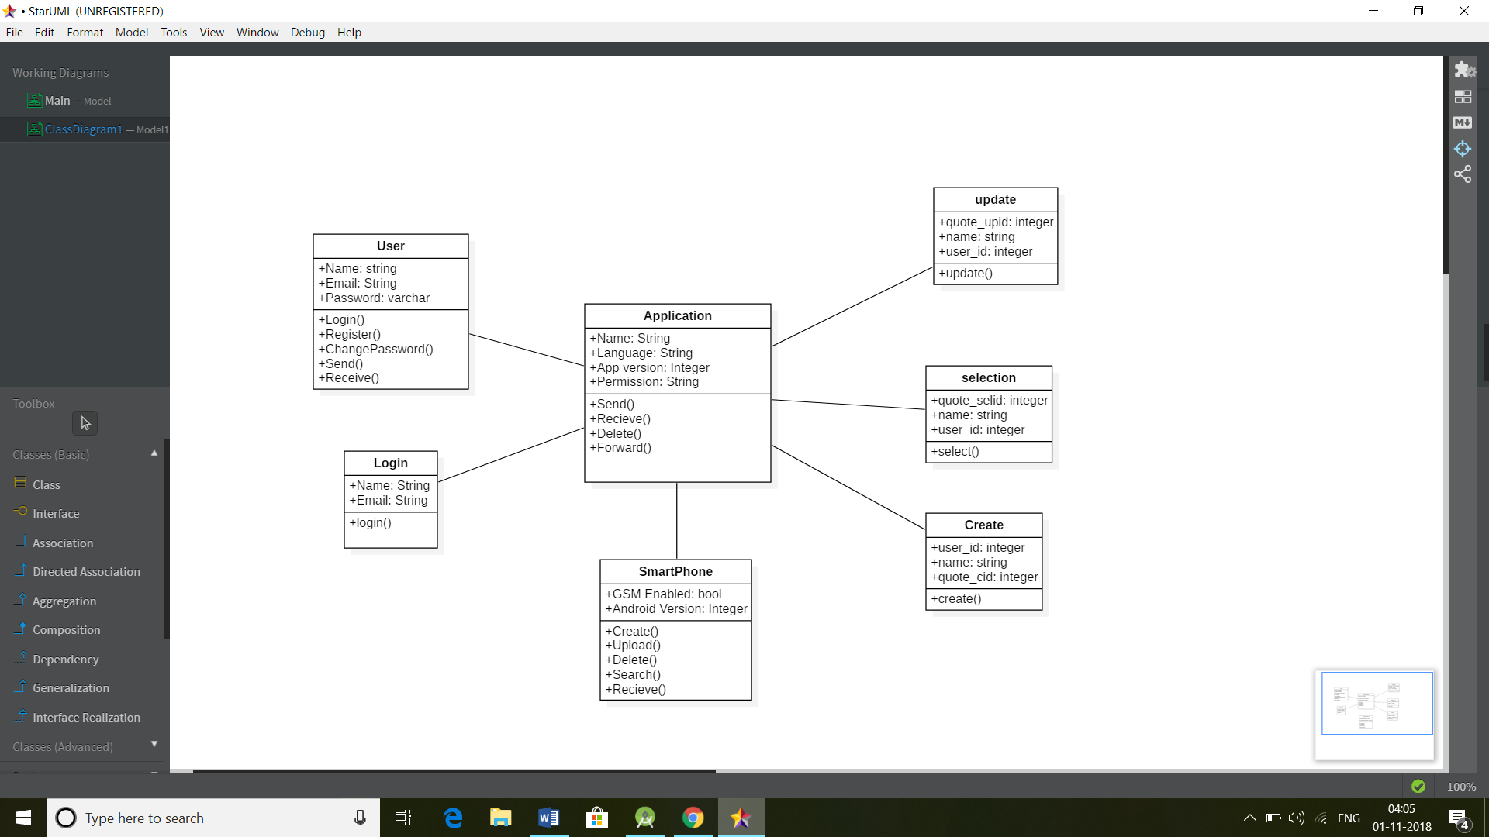

**3.2 Use case diagram**

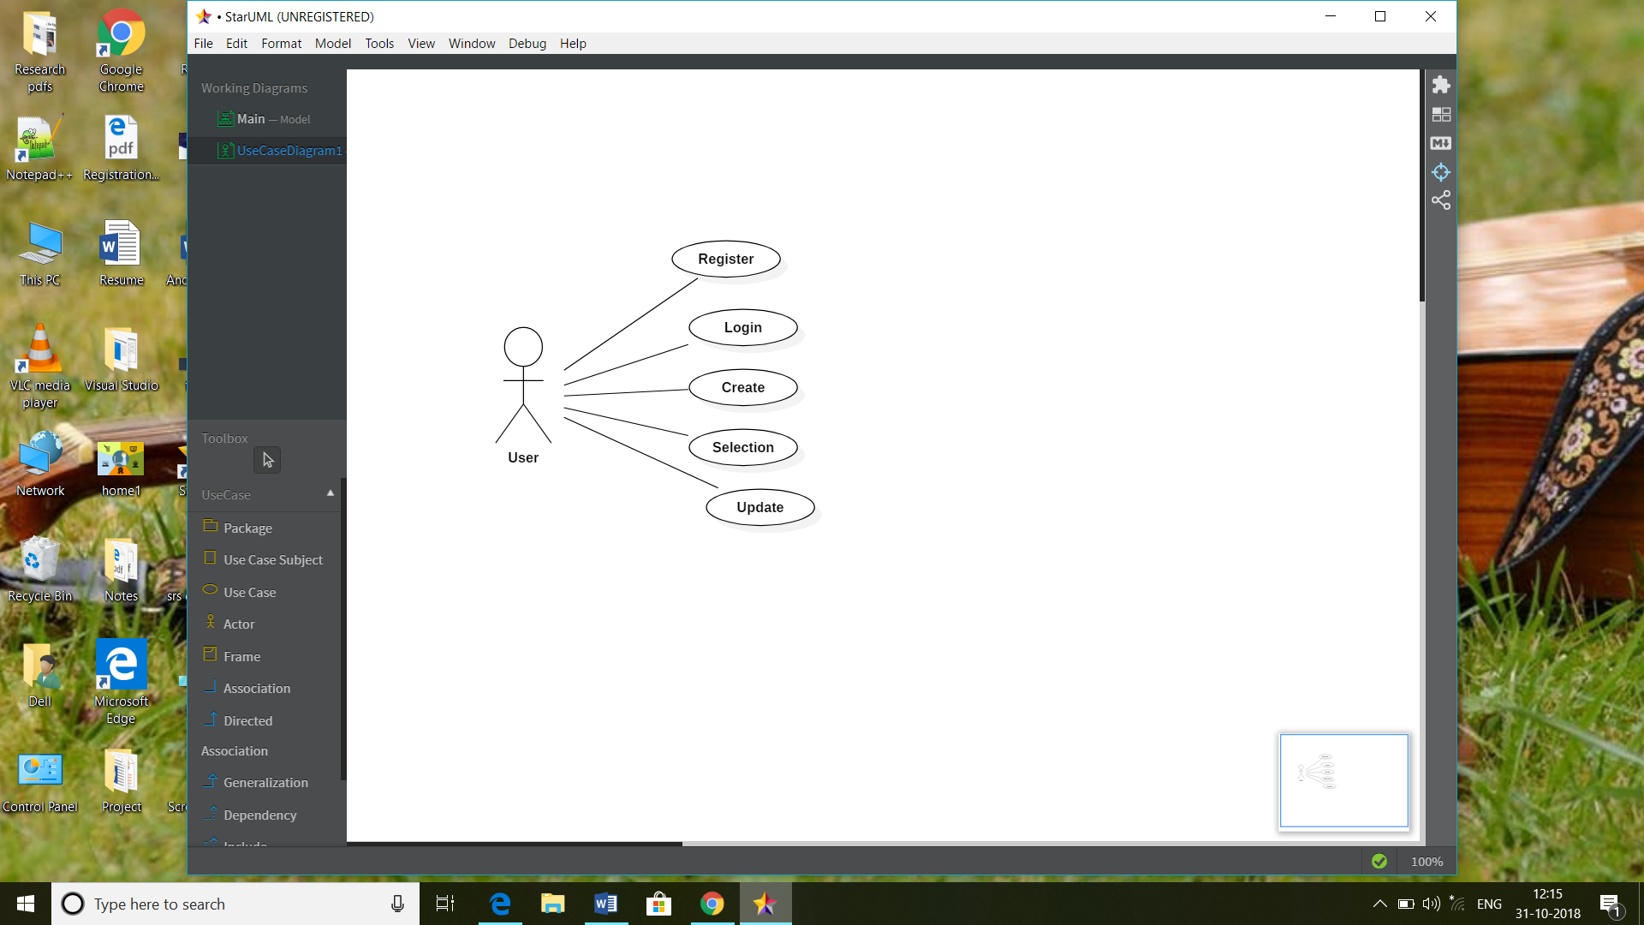

**3.3 User Requirements**

First the user will create an account and then login into their account.

1. Create

* The user can create his/her quotes.
* And view the quotes.

1. Update:

* The user after creating the quotes can do updating on that quotes.

1. Delete

* The user can delete or upgrade the created quote.
  1. **Table Specifications**

**User:**

|  |  |  |
| --- | --- | --- |
| **Name** | **Value** | **Constraint** |
| **User_id** | **Integer** | **Primary Key** |
| **User_name** | **varchar** | **Not null** |
| **User_email** | **varchar** | **Not null** |

**Application:**

|  |  |  |
| --- | --- | --- |
| **Name** | **Value** | **Constraint** |
| **App-id** | **Integer** | **Primary Key** |
| **User_id** | **varchar** | **Foreign Key** |
| **language** | **String** | **Not null** |

**4. Drawbacks and Limitations**

The drawback of the system is that the user is unable identify the plagiarism part.

The system needs a big data database to store all the duplicate and non-duplicate data.

The filtering and sorting of data becomes difficult.

1. **Proposed Enhancements**

The future enhancement of the project is to make user enable of the data about the quotes uploaded.

The user will be notified as from where and what time the quote has been copied or uploaded with the same credentials.

The user will be able to copyright his/her quote once quoted to avoid plagiarism.

1. **Conclusion**

This project will enable user to put their thoughts and ideas on a platform where everything will be provided. The user just needs to click the button and the job would be done.

The project still needs to be upgraded and the system will improve in future.

1. **Bibliography**

* <https://www.javaworld.com>
* <https://www.quora.com>
* <https://www.mindstick.com>

**Annexures**

**Annexure 1: Output Reports with Data**

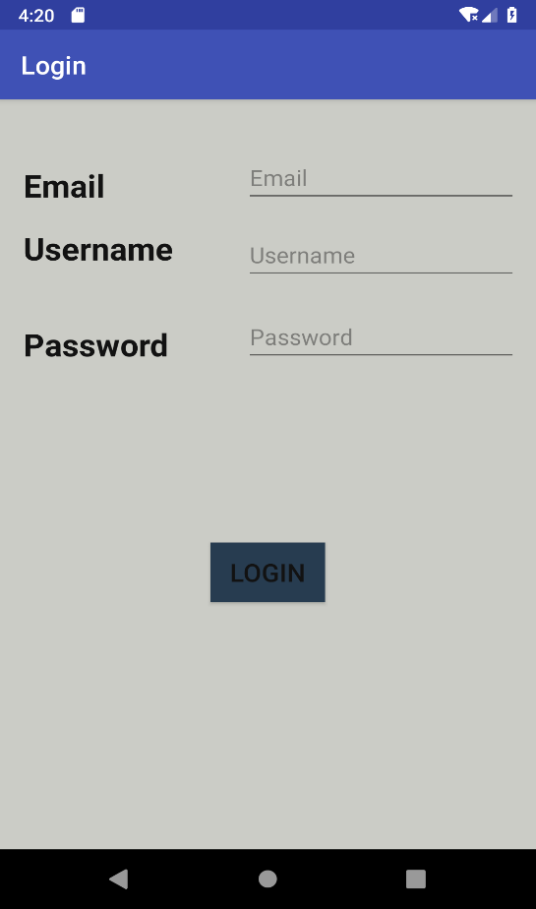

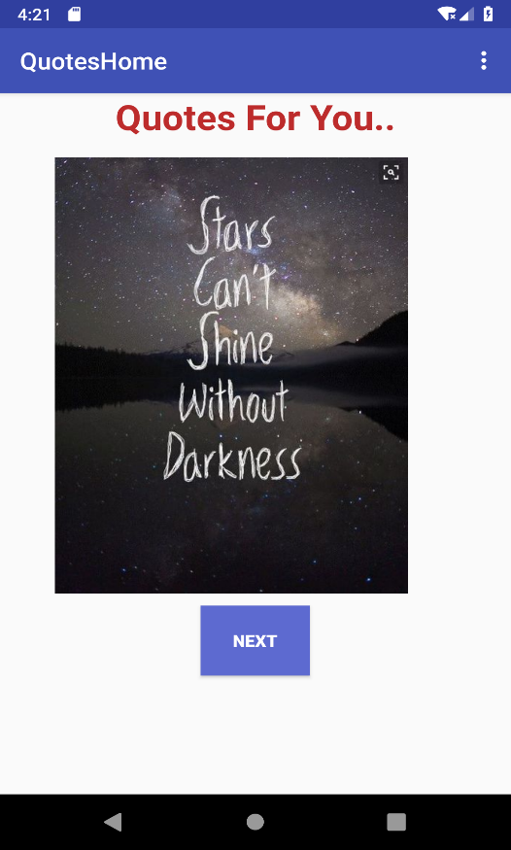

**Annexure 2: Program Code**

Content_home.xml

*<?*xml version="1.0" encoding="utf-8"*?>*<LinearLayout xmlns:android="http://schemas.android.com/apk/res/android"  
 xmlns:app="http://schemas.android.com/apk/res-auto"  
 xmlns:tools="http://schemas.android.com/tools"  
 android:layout_width="match_parent"  
 android:layout_height="match_parent"  
 app:layout_behavior="@string/appbar_scrolling_view_behavior"  
 tools:context=".QuotesHome"  
 tools:showIn="@layout/activity_quotes_home">  
 <RelativeLayout  
 android:layout_width="match_parent"  
 android:layout_height="match_parent">  
  
 <TextView  
 android:id="@+id/textView1"  
 android:layout_width="match_parent"  
 android:layout_height="match_parent"  
 android:textAlignment="center"  
 android:text="Quotes For You.."  
 android:textColor="#bd2c2c"  
 android:textSize="30dp"  
 android:textStyle="bold"/>  
  
 <ImageView  
 android:id="@+id/quote1"  
 android:layout_width="284dp"  
 android:layout_height="486dp"  
 android:layout_alignParentStart="true"  
 android:layout_alignParentTop="true"  
 android:layout_marginStart="44dp"  
 android:layout_marginLeft="40dp"  
 android:layout_marginTop="0dp"  
 android:layout_marginRight="20dp"  
 app:srcCompat="@drawable/quote1" />  
  
 <Button  
 android:id="@+id/nxt_btn"  
 android:layout_width="wrap_content"  
 android:layout_height="60dp"  
 android:layout_below="@+id/quote1"  
 android:layout_centerHorizontal="true"  
 android:layout_marginTop="-45dp"  
 android:text="Next"  
 android:textColor="#FFFFFF"  
 android:textStyle="bold"  
 android:background="#5d6ad0"/>  
  
  
 </RelativeLayout>  
  
  
  
</LinearLayout>

Quotes.java

package com.example.dell.myproject;  
  
import android.content.Intent;  
import android.os.Bundle;  
import android.support.design.widget.Snackbar;  
import android.support.v7.app.AppCompatActivity;  
import android.support.v7.widget.Toolbar;  
import android.view.View;  
import android.view.Menu;  
import android.view.MenuItem;  
import android.widget.Button;  
  
public class QuotesHome extends AppCompatActivity {  
 Button next;  
  
 @Override  
 protected void onCreate(Bundle savedInstanceState) {  
 super.onCreate(savedInstanceState);  
 setContentView(R.layout.*activity_quotes_home*);  
 Toolbar toolbar = (Toolbar) findViewById(R.id.*toolbar*);  
 setSupportActionBar(toolbar);  
  
 next = findViewById(R.id.*nxt_btn*);  
 next.setOnClickListener(new View.OnClickListener() {  
 @Override  
 public void onClick(View v) {  
 openquotes();  
 }  
 });  
 }  
  
 public void openquotes() {  
 Intent Intent = new Intent(this, quotes2_home.class);  
 startActivity(Intent);  
 }  
  
 @Override  
 public boolean onCreateOptionsMenu(Menu menu) {  
 getMenuInflater().inflate(R.menu.*menu_main*, menu);  
 return true;  
 }  
}